Examination: VII Sem. B.Tech (Mining Engineering) Session: 2022-23
Semester: Monsoon Semester Max. Marks: 100
Subject: Mine Systems Engineering MND 404 Time: 3 Hrs.
Section 1 (Attempt any 2 Questions OUT OF 3) Total Marks 40

Problem #1 Networks Total Points (10) points for each sub part
For the given activities determine:
1. Calculate expected time, variance and standard deviation for each activity.
2. Design the critical path with EF and LS and slack mentioned on each activity clearly using PERT and total expected duration and variance in days of critical path
3. Calculate the probability of completing the project in 26 days.
Activity | t_{o} | t_{m} | t_{p}
1-2 | 6 | 9 | 12
1-3 | 3 | 4 | 11
2-4 | 2 | 5 | 14
3-4 | 4 | 6 | 8
3-5 | 1 | 1.5 | 5
2-6 | 5 | 6 | 7
4-6 | 7 | 8 | 15
5-6 | 1 | 2 | 3
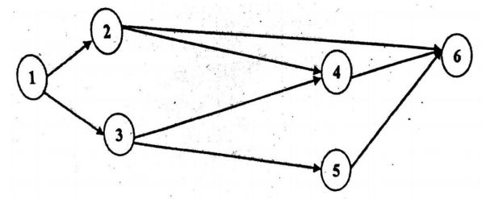

Problem #2 Total Points (20) 10 points for each sub part
- Show all iterations and steps involved in the solution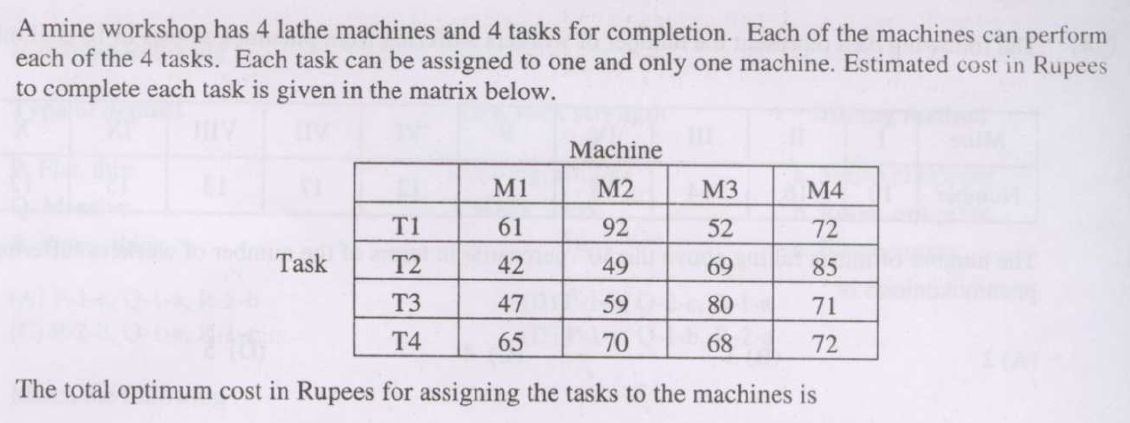

- Clearly show all the steps involved for arriving at the solution, starting from whether the problem is balanced or not.
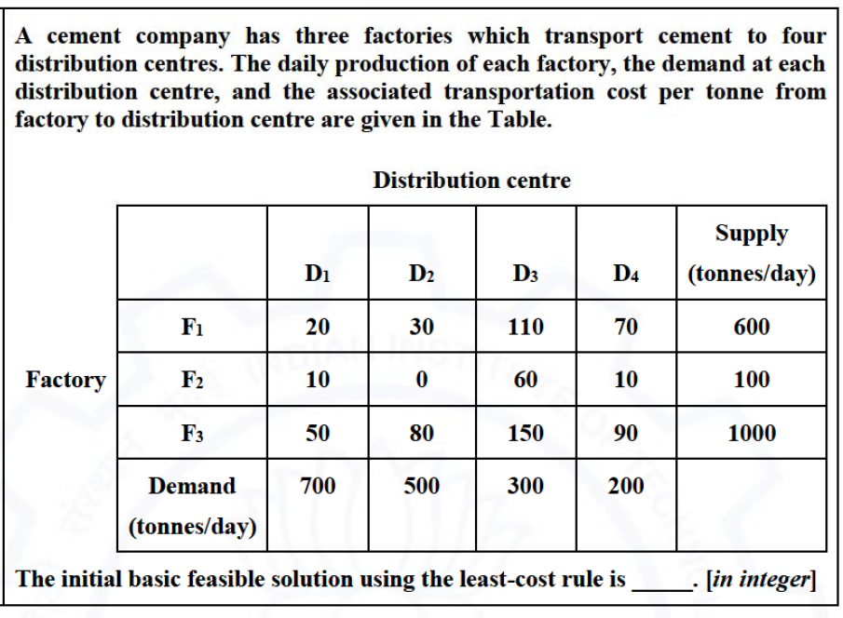

Problem #3 Total Points (20)
- Solve all the parts with 2 points for each subpart. (10 points)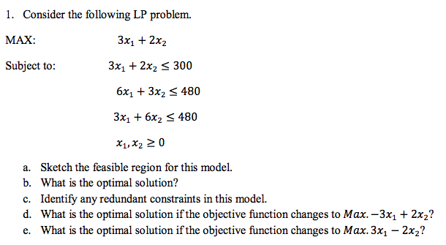

- What is the max value of the objective function and why? (5 points)
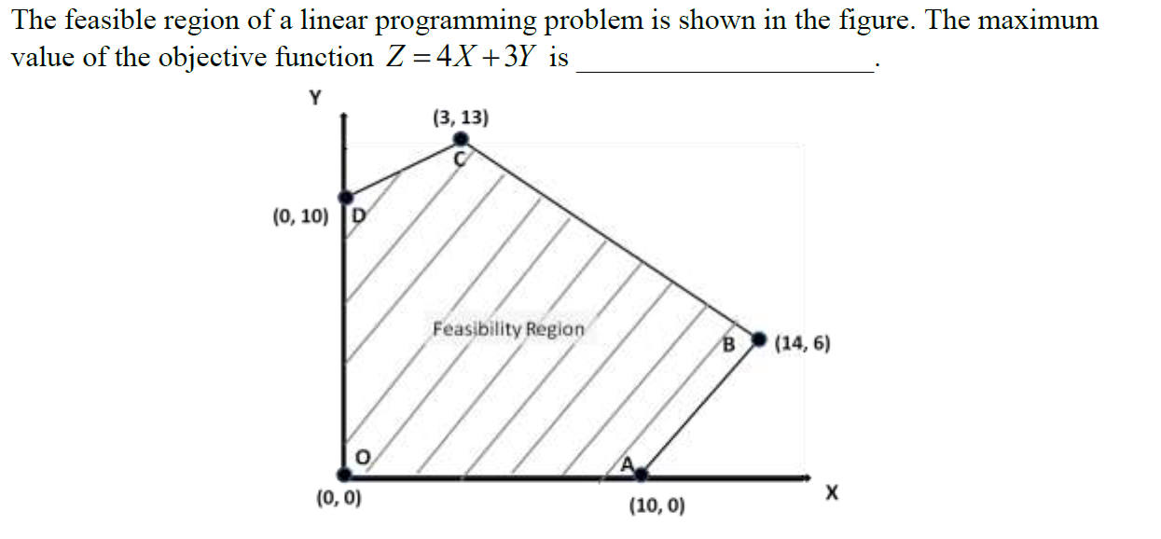
- Write the dual of this primal LP using variables y1, y2 etc.. (5 points)
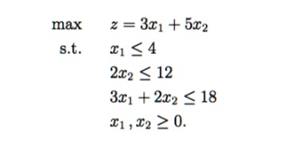
SECTION 2 ALL Questions are COMPULSORY (TOTAL MARKS 60)

Problem #4 Total Points (10) 5 points for each sub part
- What is the vision of Coal Logistics Policy 2022 issued by the Ministry of Coal? and List the Key objectives of the coal logistic policy

- Calculate the expected value of a E (3X+5) for a random variable x using the data given below:

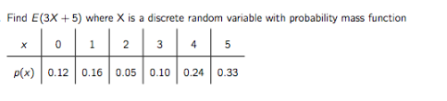
Hint: E [aX + b] = aE[X] + b.

Problem #5 Total Points 10 points
Consider the following directed, weighted graph:
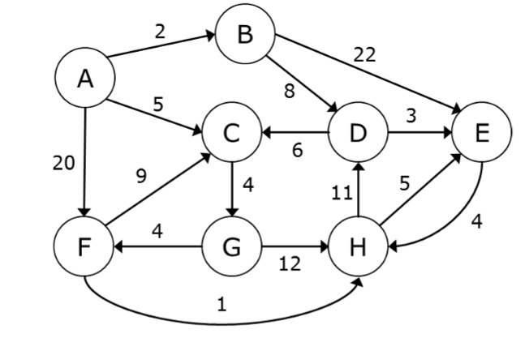
Use Dijkstra’s algorithm to calculate the single-source shortest paths from vertex A to every other vertex. If during your algorithm two unvisited vertices have the same distance, use alphabetical order to determine which one is selected first.
Problem #6 Points (20) 10 points for each sub part
Compute two minimum spanning trees for the following undirected, weighted graph
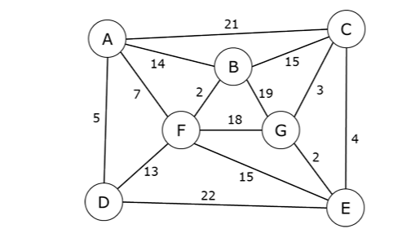
- Step through Prim’s algorithm to calculate a minimum spanning tree starting from vertex A. Show your steps clearly and results. 10 points
- Step through Kruskal’s algorithm to calculate a minimum spanning tree of the graph. Show your steps at each iteration. 10 points
Problem #7 Points (20) 10 points for each sub part
- Thousands of items are held in inventory by a mine, but only a small % of them deserve management’s closest attention and tightest control. Please divide them into three classes A,B, and C based on the following approximate criterion:
- A Items – typically 15 % of the items accounting for 70% of the inventory value-use Q system
- B Items – typically an additional 25 % of the items accounting for 15% of the inventory value
- C Items – Typically the remaining 60 % of the items accounting for only 15 % of the inventory value
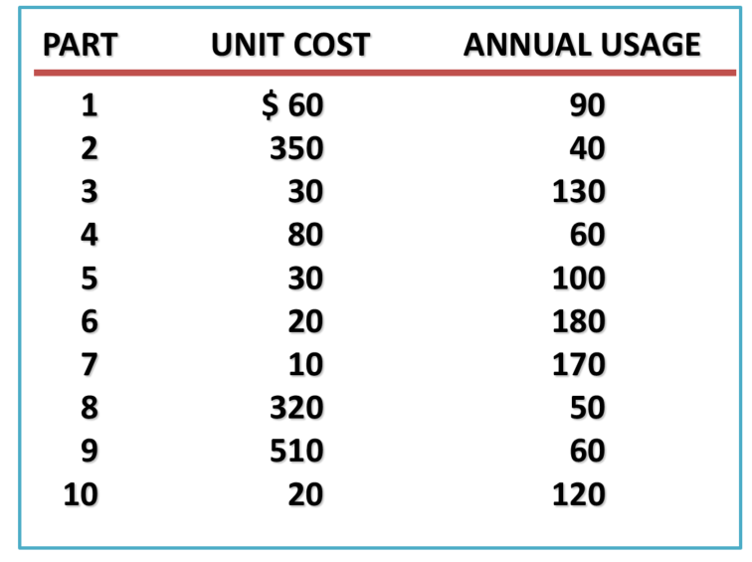
Clearly mention the results of each class and how you arrived at the solution.
- Using the quantity discount model for EOQ suggest which option should a mine manager take for ordering the items for inventory purposes based on different discounts :
- annual demand = 100 units/year
- Ordering cost = $45 per order
- Holding cost per year = 20% of item cost
- Quantity discounts:
Order quantity | Cost per item
50 or less | $18
51 to 99 | $16
100 or more | $12

Draw the total cost curve vs. order quantity to explain your answer
List of formulae
Without shortage
